Immune aging in long-lived and short-lived populations of *Drosophila melanogaster*

____________________________________

A Thesis

Presented to the

Faculty of

California State University, Fullerton

____________________________________

In Partial Fulfillment

of the Requirements for the Degree

Master of Science

in

Biological Sciences

____________________________________

By

Elnaz Bagheri

Thesis Committee Approval:

Parvin Shahrestani, Department of Biological Sciences

Nilay Patel, Department of Biological Sciences

Catherine Brennan, Department of Biological Sciences

Spring, 2020

Abstract

Bacteria, viruses and fungi create infectious diseases that cause morbidity and mortality. Strength of immune defense at different ages can effect on the rate of mortality. This research focuses on three questions using fruit flies, *Drosophila melanogaster,*as the study system. First, what is the relationship between longevity and immune defense in short-lived and long-lived *D.melanogaster*populations? Second, what is the effect of chronological age on immune defense in short and long lived populations? Third, does experimental evolution for longevity differentiation disproportionately affect immune defense genes? *D. melanogaster* populations were experimentally evolved to become differentiated in aging rates, and consequently in longevity. Then five replicate short-lived populations were compared to five replicate long-lived populations for differences in immune defense against the fungal pathogen *Beauveria bassiana*. Immune defense was measured as survival after inoculation with *B. bassiana* and this character was measured at multiple ages throughout the lifespan for all ten populations. Post-infection survival was lower in short-lived populations at all chronological ages compared to the same ages in long-lived populations, and post-infection survival declined with age in both short-lived and long-lived populations. Whole-genome sequence data from the five short-lived and five-long lived populations were previously used to identify genomic regions that are differentiated among these populations. We briefly explored these genomic differences for enrichment of immune defense genes, but more work is needed. Results from this study can potentially inform the use of *B. bassiana*in biological control against mosquito vectors of malaria and dengue, because of the similarities between mosquito and *D. melanogaster* immune defenses. Moreover, due to homology between the innate immunities of fruit flies and humans, results from this study can inform the need for personalized medicine, such as treating old and young patients differently after infection.

TABLE OF CONTENTS

ABSTRACT ................................................................................................................... ii

LIST OF TABLES ......................................................................................................... v

LIST OF FIGURES ....................................................................................................... vi

ACKNOWLEDGMENTS ............................................................................................. vii

Chapter

1. Immune aging in long-lived and short-lived populations of *Drosophila melanogaster..............................................................*......................................................1

Introduction .................................................................................................................... 1

Methods ............................................................................................................................5

Statistical Analysis …....................................................................................................... 7

Results ………................................................................................................................... 10

Discussion……............................................................................................................... 17

LIST OF TABLES

Table Page

LIST OF FIGURES

Figure Page

Acknowledgement

I would like to thank my thesis advisor Dr. Parvin Shahrestani who assisted me at any time under any circumstances in my Master’s project. I did not only learn evolution of aging in Dr. Shahrestani’s Lab, I also learned the meaning of responsibility, team work, friendship and leadership in her lab.

Chapter 1

Introduction

The causes of aging have been under investigation for many years. Some theories explain aging as an accumulation of cellular and molecular damage during lifespan (Johnson et al. 1999). For example, the free radical theory of aging suggests that oxidative damage to molecules results in aging, which happens due to reactive oxygen species (ROS) byproducts of different cellular processes like metabolism. The idea is that cellular processes could cause damages that result in imbalances in cellular components and imperfections of biomolecules (Gladyshev, 2012; Gladyshev, 2013), and that these damages lead to aging (Stadtman, 1992). Such damage-based theories of aging assume that aging is an unavoidable process, thus all organisms should age. However, some organisms do not age. In particular, organisms that reproduce by binary fission, such as unicellular bacteria, and organisms that reproduce by budding, such as hydra, seem to be able to avoid aging. Moreover, humans and other sexually reproducing organisms experience periods of life when mortality rates are stable, such as during development and during late adulthood, which suggest that there is no inevitable accumulation of molecular damage that causes aging. Replicative senescence theory of aging is similar to other theories of cellular aging. This theory expects organism’s aging happen due to changes in cellular function. In cellular aging, the decline and finally loss of cell division has been observed and a period identified as replicative senescence. When the population of cells in culture lost their ability to double during four weeks, cells are supposed to have reached “replicative senescence”. However, it does not mean that all cells in the population lost their division ability, just that the majority have. Based on the replicative senescence theory of aging whole organisms must age because cells age. while there is some evidence against this theory. As an example, interspecies comparisons demonstrate that population doubling rates differ with the species, but difference in population doubling rates was not correlated with different species life span.

The presence of cell lines demonstrates that not all cells senesce. Cancer is an interesting example for age-associated diseases which happening more often in older people compared to younger individuals, while cancer cells don’t senesce. Senescent cells characteristically show increase in the size of cells. In addition, the distance between senescent cells becomes greater, and the decrease in viable extracellular matrix proteins cause slowing of replication. Totally, cellular function decrease in a senescent population that contains reductions in the rate of DNA, RNA, and protein synthesis. Accordingly, it is not well-defined how a model of aging based on the termination of cell division inserts precious evidence about a procedure that happens essentially in the absence of cell division. Although supporters of the replicative senescence theory often believe the fact that population doubling rates associate with a species’ life span, it was discussed already that these associations are very weak at best and do not happen in all species. Moreover, both mitotic somatic cells taken from old individuals and mitotic somatic cells taken from young individuals can frequently display robust population doubling rates similarly. Based on telomere-shortening theory of aging, frequent replication of a chromosome make the telomeres too short in which no more replication can happen without touching the coding sequence of the DNA. In this theory, cells stop dividing and/or die at the end of telomere-shortening when telomeres have been shortened too much and it cause organismal aging. Mitotic clock theory of aging is based on short telomeres in senescent cells and lack of telomerase in somatic cells which stops cell division. G1/S checkpoint which is the first checkpoint of cell cycle will be inhibited by short or uncapped telomeres. This theory is very similar to telomere-shortening theory. In this theory, cells stop dividing when their telomeres are short before any damage affects to the parts of the chromosome that code for genes while in telomeres-shortening theory cells get to somehow sense when telomeres are getting shorter. Mitotic clock theory might be the reason that cells stop dividing after a given number of population doublings. Thus, this theory is related to replicative senescence theory. Another theory of aging is known as Endocrine. Based on this theory pace of aging is controlled by hormones and the evolutionarily conserved insuling/IGF-1 signaling (IIS) pathway has a significant role in the regulation of aging by hormones. Wear and tear theory of aging that was presented by Dr. August Weisman for the first time in 1882, explain that aging happens due to deterioration of fundamental parts of cells and tissues. In this theory, they used car as an example for body. It was described that like components of an aging car; different parts of the body finally wear out because of frequent use and it kills them and then the body. Rate of living theory is another theory of aging that believes organisms with fast rates of metabolism will shorter life span than individuals with lower rates of metabolism. Cross-linking theory explains that accumulation of cross-linked proteins hurts cells and tissues which it slows down physical progression and finally cause aging. Recent studies on this theory demonstrates that some age-related changes like changes to skin are because of cross-linking reactions.

Evolutionary biology presents a logical, truly developed, and experimentally validated theory for biological aging (Rose et al. 2008). Under evolutionary theories of aging, the absence of aging in fissile organisms and at late adult ages are not only explainable, but are also predictable. In the evolutionary theories, aging is thought to result from a detuning of adaptation, such that older individuals are less adapted to the environment compared to younger individuals. The difference in adaptation across the age classes results from differences in fitness, since natural selection acts on fitness differences to produce adaptations. From zygote until the first age of reproduction in a population, the fitness potential is high and all reproduction will happen in the future, by definition. Therefore, the force of natural selection is high and constant throughout the developmental period. Then the force of natural selection starts to decline from the first age of reproduction in a population, and steadily decreases toward zero. Finally, at the last age of reproduction in a population, or when parental and/or grandparental care becomes irrelevant for fitness (in species to which this applies), natural selection reaches zero, or values near zero where the effect of selection is weaker than the effects of genetic drift.

During the developmental period when the force of natural selection is high and constant, the mortality rate is thought to be age-independent (or background) mortality. From the first age of reproduction when the force of natural selection decreases steadily, mortality rate starts to increase. When the forces of natural selection are declining, it means that selection can no longer eliminate deleterious mutations as effectively. In other words, deleterious mutations that have impacts that are limited to late ages are already passed to the next generation through the reproduction time, before the negative old age signs would become obvious. As an example, if a deleterious mutation has its impact after the first age of reproduction and causes a disease and death at the middle age, the force of natural selection does not have the ability to eliminate that mutation from the population because already some of these genes have been passed to the next generation after the first day of reproduction. Moreover, antagonistically pleiotropic genes that have beneficial effects early in life remain in the population even if they have deleterious effects late in life due to selection being weaker at older ages. Mortality rates peak by the end of the reproductive period when the force of natural selection reach near zero. After the last day of reproduction, during the late-life period, mortality rates stabilize into a plateau. The plateau in mortality rates late in life coincides with the plateau in the forces of natural selection after the last age of reproduction in a population. At these late ages, natural selection is ineffective and its impact is overcome by random genetic drift.

Evolutionary theory predicts that when the first age of reproduction is delayed in a population, the population should evolve to delay the onset of aging later and live longer. This prediction has been experimentally validated using *D. melanogaster* (Rose 1984), such that populations in which the first age of reproduction was postponed from 14 days to 70 days lived significantly longer than the control populations which continued to reproduce at 14 days old. Moreover, the evolutionary theory for late life predicts that populations with later last ages of reproduction should have a later onset of the mortality plateau, which is also experimentally supported in *D. melanogaster* (Rose and Mueller 2000, LD. Mueller and MR. Rose , 1996). Evolutionary theory predicts that all fitness characters should deteriorate during aging and plateau in late life, not just survival. Indeed male virility and female fecundity, both measures of reproductive output, deteriorate during aging and plateaus in late life (Shahrestani et al.2012, Rauser et al. 2006).

An alternative theory for late life plateaus in fitness characters is knows as the lifelong heterogeneity theory. This theory suggests that subgroups of a population have different robustness measures and the most robust groups die later. In this theory, the stabilization of fitness characters in late life is a side effect of the most frail subgroups having already died off and the most robust subgroups remaining in the population. However, this theory of aging is not a strong theory and it cannot explain late life mortality correctly because it is very difficult to identify and test “robustness.” Its mathematics also looks to be noticeably elastic. Moreover, this theory suggests that late life plateaus are a demographic effect and that fitness characters should not plateau for individuals. However, experimental data shows that individual female’s fecundity declines during aging and plateaus in late life. Therefore, late life is not just a demographic effect of population subgroups. There are some evidences against heterogeneity theory of aging. For example, one experimental plan was done to change heterogeneity artificially to examine the effects of these changes on mortality rate as a function of age. In this experiment, a brief heat shock was used to make flies with vaster heterogeneity in their mortality rates. As a result, it was noticed that the increased heterogeneity causes no changes in later mortality rates (Khaezeli *et al.* 1995*b*). Another study was done to test effects of heterogeneity on mortality-rate plateaus and used different design. 15 populations were used that their differentiation in starvation resistance correlated with variation in longevity (e.g. Service *et al.* 1985; Rose *et al.* 1992). Based on heterogeneity theory of aging, it was expected that more robust cohorts should have lower mortality-rate plateaus than less robust cohorts. However, the results of this study did not show any significant difference in the mortality rates late in life of cohorts with a great divergence in robust-ness (Drapeau *et al.* ,2000). Moreover, studies on genetically homogeneous populations of *D.melanogaster* shows that populations with reduced genetic and environmental variation still get mortality plateaus.

*Drosophila melanogaster* is a useful model to study immune defense because of its great assortment of genetic tools (Kounatidis et. al 2012) and its similarity to human innate immune defense (Buchon et.al 2014). The immune defense is an important system that makes amazing contributions to the entire body such as its highly intensive response system to pathogens. The *D. melanogaster,* like many other insects has strong immune system against microbes that helps them to live in an environment with plentiful of fungi, viruses, and bacteria (Kleino et. al 2014). Epithelial barriers such as cuticle, trachea, and gut are known as first-line defenses against microorganisms. Microorganisms that can pass the epithelial barriers and arrive to the general body cavity (hemocoele) will be responded to by both cellular and humoral defenses. The cellular defenses include phagocytosis by plasmatocytes which are macrophage-like cells, and encapsulation by lamellocytes which are specialized to attack larger microorganisms. The melanization cascade which is an important cascade among proteolytic cascades, locally produces quinones and toxic oxygen intermediates and comes to a head of melanin production around microorganisms or at wound spots. Numerous proteolytic cascades also are involved in the humoral reactions. The systemic antimicrobial reaction is known as the hallmark of the humoral defenses. The humoral reactions such as production of antimicrobial peptides happen mainly in the fat body in *Drosophila*. *Drosophila* use most of the Toll pathway’s components against fungal and Gram-positive bacterial infections. There are specific types of fungi that cause deadly infections in fruit flies. *Beauveria bassiana* is one of them which is an entomopathogenic fungus and grows naturally in soils (Sookar et.al 2008). *B. bassiana* has been shown to have potential uses against human disease vectors such as the mosquitos that vector malaria and dengue, and also against insect crop pests.

In *D. melanogaster*, susceptibility to fungal infection increases with aging (Kubiak and Tinsley 2018). In *D.melanogaster* the ability to tempt an antimicrobial defense decreases with age, suggesting that innate immunity deterioration is an essential feature of aging (Zerofky et al. 2005). Moreover, vaster risk of infection was observed in aged flies, which could contribute to their increased mortality-rate (Zerofsky et al.2005). There appears to be no change in bacterial clearance ability with age, but the ability of a fly to survive an infection decreases with aging (Ramsden et al.2008). In contrast, some other studies found that bacterial infection clearance ability will improve by aging and older flies illustrate a better immunity in reference to lower bacterial load (Lesser et al.2006, Khan et al. 2012).

Most existing studies about *D. melanogaster* immune system during aging compare young and old flies from the same populations, and thus are confounded by the effects of cumulative exposure to pathogens as flies age. However, populations of *D. melanogaster* exist which are experimentally evolved to differ in aging patterns and are differentially aged at the same chronological age. These populations allow experimenters to control for cumulative exposure to pathogens and other time dependent host-microbe interactions. One such set of populations is the ACO1-5 (A-type) and CO1-5 (C-type) populations (Chippindale et al. 1997). the A-type populations were selected for an earlier first age of reproduction (10-days) compared to that of their CO type ancestral populations which have later first age of reproduction (28-days). In line with expectations from the evolutionary theories of aging, selection for early reproduction resulted in faster aging and shorter lifespans in the A-types compared to the C-types. The A and C types differ in generation time, which is defined here as the time from egg to eggs of the next generation. The A types begin aging at earlier ages, age at faster rates, enter the mortality plateau at earlier ages, and die at younger ages compared to the C types. The short-lived A types have also become smaller in body size and less resistant to various stressors compared to the C types (Shahrestani et al. 2016, Shahrestani et al. 2017).

Studies of aging that compare young and old flies from the same population are looking at “chronological” aging, which can be affected by extended interactions with the biotic and abiotic factors in the environment. Populations that have evolved to age at different rates may allow us to separate biological aging from the effects of time and cumulative exposure. In this study, we examined the effects of chronological aging and biological aging on immune defense in *Drosophila melanogaster*. We focused on three questions in our study: (I) What is the relationship between longevity and immune defense in long-lived and short-lived populations? (II) What is the effect of chronological age on immune defense in long-lived and short-lived populations, and (III) Does experimental evolution for longevity differentiation result in genomic differentiation that includes an overrepresentation of immune defense genes? We expect that long-lived populations will have better immune defense than short-lived populations at all ages. We also expect that older flies will die faster from infection than younger flies and that this age-related increase in susceptibility to infection will happen faster in the short-lived populations compared to the long-lived populations. Lastly, we expect that the genomic differentiation of the long- and short- lived populations will be enriched for immune defense genes.

Chapter 2

**Methods:**

*Drosophila melanogaster* populations

All of the *Drosophila melanogaster* populations used in this research are derived from an ancestral population called IV, which was collected from an apple orchard in Massachusetts (Ives 1975). Five populations called O1–5 populations were derived from the IV by postponing the first age of reproduction from 14 to 70 (Rose, 1984). Then, five replicate populations called CO1–5 were derived from the O1–5 populations and were selected for first age of reproduction at age 28. From the CO1–5, another five replicate populations, called ACO1–5 were derived and selected for first age of reproduction at 10 days. Aligned with the expectations of the evolutionary theories, the ACOs are shorter lived than the Bs, which are shorter lived than the COs, which in turn are shorter lived than the Os. In this study we use the ACO1-5 and CO1-5 populations. Note that all of these populations are on discrete generation cycles, which means that their first and last age of reproduction is the same as their generation time, defined as the time from eggs of one generation to eggs of the next generation.

All these populations are large and outbred, with at least 1000 individuals per generation. Prior to each experiment, all populations were put through two controlled rearing generations to eliminate environmental and parental effects, as follows: eggs were collected and flies were allowed to develop for 13 days before being transferred to cages and provided with banana-molasses diet (1 Liter of DI water, agar (15.15 g), yeast (36.36 g), Banana (136.36 g), light syrup (0.30 scoops), dark syrup (0.30 scoops), barley malt (0.45scoop), DI water (69.68 ml), 95% Ethanol (24.22 ml), Antifungal (2.36 g), Ethanol (23.63 ml))food. A yeast supplement was added to the top of the food to stimulate egg laying. After one day in the cages, we collected eggs and again waited for 13 days, and then transferred flies to cages with yeasted banana-molasses food. After one day we collected vials of eggs again for each of the 10 populations, and the number of vials depended on the experiment. In these controlled rearing generations, the generation time was 14 because that is the ancestral generation time of the IV. After the controlled rearing generations, 13 days from egg, flies were transferred from vials to large cages with 20 vials of flies transferred to each cage, and thus the densities in the cages were ~1500-2000 flies per cage. Here was explained how our experimental populations were derived from an ancestral population.The IV population was an ancestral population of *D.melanogaster* which was collected from an apple orchard in Massachusetts (Ives 1975). Five replicates of O population were derived from IV populations in 1980. O1-5 populations maintained on 70-day generation cycles. In 1989 five replicates of CO populations were derived from O1-5 populations and they maintained on 28-day generation cycles. After that five replicates of ACO populations were taken from CO1-5 populations and maintained on 10-day generation cycles. AO1-5 and nCO1-5 populations are new populations that recently derived from O1-5 populations and they maintained on 10-day and 28-day generation cycles respectively. As AO1-5 and nCO1-5 are recently derived populations, they have undergone their selection regimes for fewer generations than the ACO1-5 and CO1-5 populations.ACO1-5, CO1-5, AO1-5, and nCO1-5  undergone their selection regimes for 738, 290, 146, and 37 generations respectively. The genomic data from all these 20 populations were used in this study to find out the correlations of immune and aging genes.

I

*Fungal Spray:*

For this project, large numbers of flies needed to be inoculated with controlled doses of *B. bassiana*. To facilitate these large-scale inoculations, a device called the “Spray tower” was custom built (by Aaron Daveler from the Department of Biological Science and undergraduate student Quang Doan). The Spray tower includes an air filter that works similarly to a fume hood, in that it clears the air inside the chamber of any airborne particles that might interfere with the ongoing experiment, a flow meter that regulates the strength of air flow (or suction) in the spray tower, and a spray nozzle which is used to delivers the dosage of fungus to flies by spraying the dosage in liquid form as a mist, A tubing extends from the flow meter through the spray nozzle and is open on the opposite end. When the air source is turned on, the air flowing through the tube and nozzle creates a vacuum, which is used to suction a fungal suspension into the spray tower. Arotating disk is located at the base of the spray tower. Curing an assay, the flies are placed on a dish of ice on top of this disk. Using this device helps to inoculate thousands of fruit flies simultaneously, and the inoculation dose, at spores per mm2 is controlled.

The strain of *B. bassiana* used to inoculate the flies for the infection assay was ARSEF 12460, which was isolated from *Drosophila melanogaster* (Shahrestani and Vandenberg, Ithaca NY). For all inoculations in this study, 0.36g of *B. bassiana* spores were suspended in 30ml of 0.03% Silwet in DI water. Then 5ml of this suspension was used to spray the flies (see methods of Vandenberg et al. 1996). Briefly, flies were anesthetized using Carbon Dioxide and placed on Petri Dishes on an ice tray. The tray was then placed into the Spray tower and the fungal spore suspension was sprayed into the chamber and allowed to fall onto the flies. The approximate dose of *B. bassiana* was estimated by placing a microscope slide adjacent to the flies during the spray, then suspending this slide in 0.03% Silwet, transferring 10 uL of the suspension to a microscope slide, and counting the number of spores. The inoculations introduced ~103 spores/mm2. After inoculation, the flies were kept at 100% humidity, dark, and 25°C for the first 24 hours to allow the fungus to germinate. Some of the fungus then presumably entered the cuticle and proliferated through the hemocoel. The control populations undertook the same treatment as the selected populations, but were sprayed with just 0.03% Silwet suspension (no fungus). The Spray tower air pressure was set to 11.5 mmHg during each spray and 15 mmHg during cleaning.

The flies were prepared for sprays at different ages, specifically 14, 21, 28, 42, and 56 days from egg. For the age 14-day spray, we prepared 2 control cages (not sprayed at all), 2 un-infected cages (sprayed with Silwet), and 2 infected cages (sprayed with fungus and Silwet). For all other ages, we had 2 uninfected cages and 2 infected cages per population. After the sprays, flies were kept in small cages (volume: 450 cm3) with density of 100-150 flies per cage.

*Mortality*

We conducted mortality checks every day for all control (not sprayed at all), un-infected (sprayed with Silwet), and infected (sprayed with fungus) experimental cages. Specifically, we removed dead flies daily and recorded the number of males and females among the dead flies. We replaced food daily until all the flies in the cages died.

*Statistical Analysis*

Chapter 3

**Results**

Corroborating previous findings, ACO1-5 populations were shorter lived than CO1-5 populations (Chippindale, A. K. et al. 1997)

.

On day 14, there were two controls, uninfected and “control,” the latter didn’t receive any spray, while the former received a spray of Silwet in water. What was the different between uninfected groups and control groups? Visually it looks like in the ACO there was no difference between uninfected and control, but in the CO there was.

At all ages and for all populations, uninfected flies had higher survival than infected flies.

How do the ACO/CO compare at the ages when they were both tested?

How do the ACO change over time? How do the CO change over time? How does this change compare between the ACO vs. CO?

What sex differences are there?

Based on the results that was achieved in this study control ACO flies have similar mortality death rates in adulthood compared to previous papers (see figure 1.1). Results of un-infected group demonstrated that for day 14, deaths are like deaths in controls and for day 42 there is only two replicates because the flies are short lived all the flies died by that day and there were no alive flies for fungal spray (see figure 1.2). Results of infected ACO illustrates flies die earlier than in un-infected and control groups (see figure 1.3). Control group of CO flies shows similar mortality death rates in adulthood compared to previous papers (see figure 2.1). CO un-infected group at age 14 is not similar to control group and the reason could be because of handling, humidity, and spraying with silwet (see figure 2.2). Results of infected group of CO population displays that infected flies die faster than un-infected and control groups in this population (see figure 2.3). Survival percent graphs in ACO population show control and un-infected group completely overlap at age 14 in both male and female (see figure 3.1). This figure also demonstrates that infected flies in both male and female die faster than control and un-infected groups at all ages (see figure 3.1). ACO un-infected to infected Ratio at 50 percent survival is bigger at age 14 than age 28 and 42 which it means the survival percent differentiation between un-infected and infected groups in younger flies is more than older flies (see figure 3.2). In CO population survival percent of Un-infected group at age 14 does not overlap with control flies (see figure 4.1). However, in CO populations like ACO populations infected flies die faster than control and un-infected groups (see figure 4.1). Based on CO un-infected to infected Ratio at 50 percent survival results, it was concluded that the survival percent differentiation between un-infected and infected groups in younger flies is more than older flies (see figure 4.2). Comparison of survival percent in ACO and CO demonstrates that CO flies from all three groups of controls, un-infected, and infected at all ages live longer than ACO flies. This differentiation is more obvious in young flies than older ones (see figure 5.1). Comparing infected ACO with infected CO displays that survival percent of ACO at age 14 is completely overlap with survival percent of CO at age 42 (see figure 5.2). Moreover, median lifetime of ACO vs CO represents that ACO median lifetime at age 28 and 42 is like CO at age 56 and 70 (see figure 6). ACO and CO populations’ Mortality graphs at age 14 demonstrate that in both males and females, infected flies die faster than un-infected ones and get to the late life plateau. ACO flies in both infected ad un-infected treatment die faster than CO flies. (see Figure 7, Table 1). The 50% mortality ratio at age 14 displays that males and females infected ACO flies reach to 50% mortality rate respectively faster than other treatments and CO populations (see Table 2). Confidence interval shows a significant difference between ACO and CO populations in all treatments (See Table 3, Table 4). Mortality rate of ACO and CO populations at age 28 shows that in both males and females, infected flies die faster than un-infected ones and get to the late life plateau. ACO flies in both infected ad un-infected treatment die faster than CO flies (see Figure 8, Table 5). Comparison of ACO and CO mortality rates at age 14 and 28 display that flies at age 28 die faster than younger flies (see Figure 7, Figure 8). The 50% mortality ratio at age 28 displays that males and females infected ACO flies reach to 50% mortality rate respectively faster than other treatments and CO populations (see Table 6). Confidence interval results for flies at age 28 displays a significant difference between ACO and CO populations in all treatments (See Table 7, Table 8). Mortality rate results at age 42, 56, and 70 only shows comparison of un-infected and infected treatments in CO populations which shows infected flies die faster than un-infected ones (see Figure 9, Table 9, Figure 10, Table 12, Figure 11, and Table 15). AO populations are short-lived flies and cannot get that much old to be sprayed at age 42,56, and 70 days. The 50% mortality ratio at age 42, 56, and 70 displays that males and females infected CO flies reach to 50% mortality rate faster than other un-infected ones (see Table 10, Table 11, Table 13, Table 14, Table 16, Table 17).

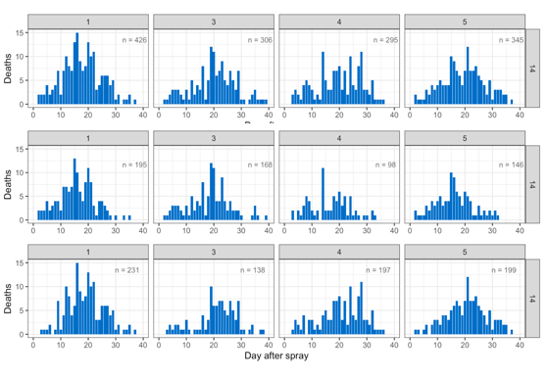

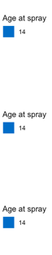

A

B

C

*Figure 1.1.* Mortality rate in ACO1-5 control flies at age 14 days. Combined sexes (A), male flies (B), and female flies (C).

X axis show day after spray and Y axis shows number of dead flies. Control group flies did not spray.

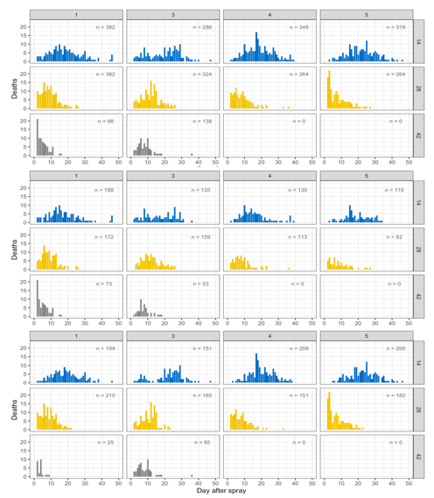

*../../../../../Desktop/Screen%20Shot%202020-03-30%20at%2010.48*

A

B

C

*Figure 1.2.* Mortality rate in ACO1-5 un-infected flies at age 14 (blue), 28 (yellow), and 42 (gray) days. Combined sexes (A), male flies (B), and female flies (C). X axis show day after spray and Y axis shows number of dead flies. Un-infected group of flies was sprayed with silwet.

*../../../../../Desktop/Screen%20Shot%202020-03-30%20at%2010.48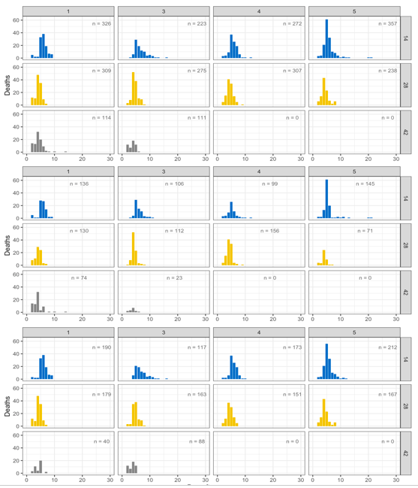*

A

B

C

*Figure 1.3.* Mortality rate in ACO1-5 infected flies at age 14 (blue), 28 (yellow), and 42 (gray) days. Combined sexes (A), male flies (B), and female flies (C). X axis show day after spray and Y axis shows number of dead flies. Infected group of flies was sprayed with fungus solution (For all inoculations in this study, 0.36g of *B. bassiana* spores were suspended in 30ml of 0.03% Silwet in DI water. Then 5ml of this suspension was used to spray the flies)

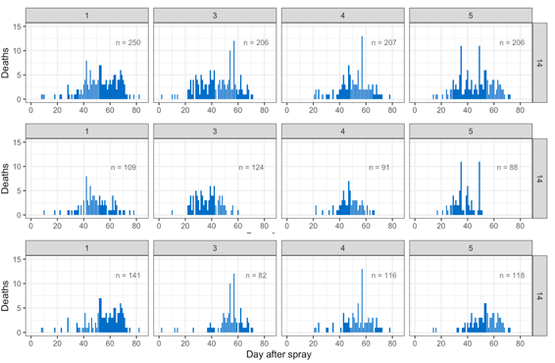



A

B

C

*Figure 2.1.* Mortality rate in CO1-5 control flies at age 14 days. Combined sexes (A), male flies (B), and female flies (C).

X axis show day after spray and Y axis shows number of dead flies. Control group flies did not spray.

A

B

C

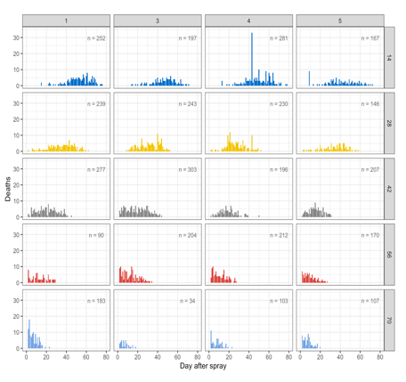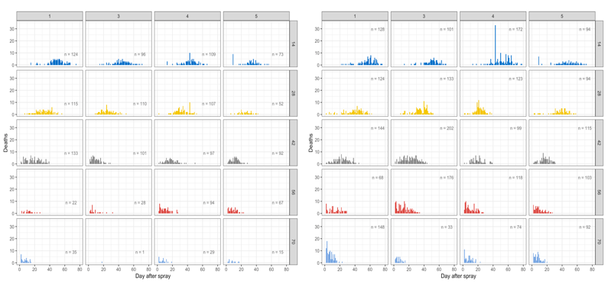

../Desktop/Screen%20Shot%202020-03-31%20at%208.54.04%20AM.png

*../Desktop/Screen%20Shot%202020-03-31%20at%208.54.04%20AM.png*

*Figure 2.2.* Mortality rate in CO1-5 un-infected flies at age 14 (dark blue), 28 (yellow), 42 (gray), 56 (red), and 70 (light blue) days. Combined sexes (A), male flies (B), and female flies (C). X axis show day after spray and Y axis shows number of dead flies. Un-infected group of flies was sprayed with silwet.

C

B

A

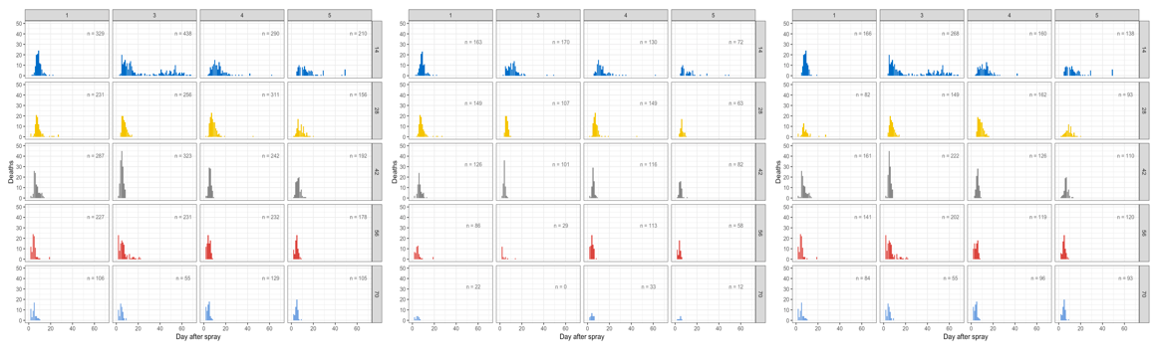

../Desktop/Screen%20Shot%202020-03-31%20at%208.54.04%20AM.png

*Figure 2.3.* Mortality rate in CO1-5 infected flies at age 14 (dark blue), 28 (yellow), 42 (gray), 56 (red), and 70 (light blue) days. Combined sexes (A), male flies (B), and female flies (C). X axis show day after spray and Y axis shows number of dead flies. Infected group of flies was sprayed with fungus solution (For all inoculations in this study, 0.36g of *B. bassiana* spores were suspended in 30ml of 0.03% Silwet in DI water. Then 5ml of this suspension was used to spray the flies)

Survival percent graphs:

B

A

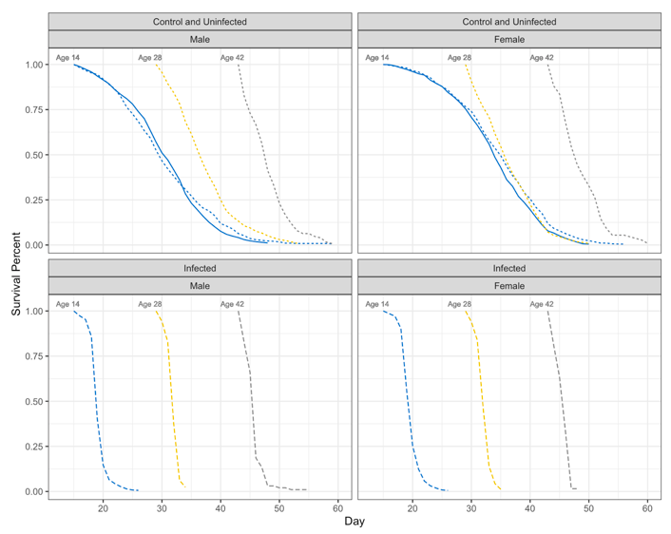

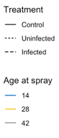

*Figure 3.1.* Comparison of survival percent of control (solid lines), un-infected (dot lines), and infected (dashed lines) ACO1-5 flies at age 14 (blue), 28 (yellow), and 42 (gray) days are shown in both panels A (male flies) and B (female flies). Y axis shows survival percent and x axis shows day. Infected graphs separated from control and un-infected graphs to be clearer

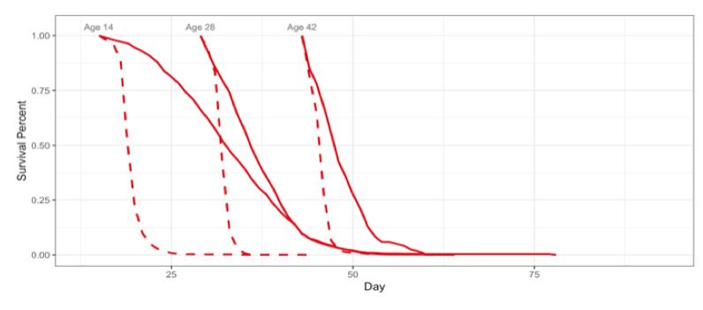

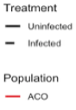

*Figure 3.2.* Comparison of survival percent of un-infected (solid lines) and infected (dash lines) ACO1-5 flies at age 14, 28, and 42 days. Y axis shows survival percent and X axis shows day.

B

A

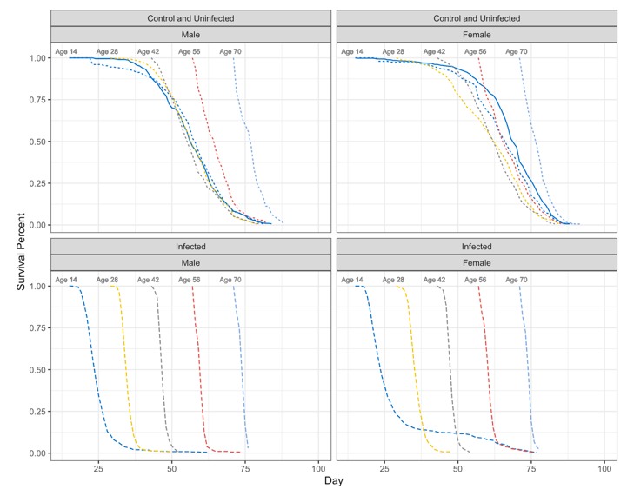

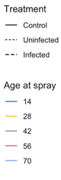

*Figure 4.1*. Comparison of survival percent of control (solid lines), un-infected (dot lines), and infected (dashed lines) CO1-5 flies at age 14 (dark blue), 28 (yellow), 42 (gray), 56 (red), and 70 (light blue) days are shown in both panels A (male flies) and B (female flies). Y axis shows survival percent and x axis shows day. Infected graphs separated from control and un-infected graphs to be clearer.

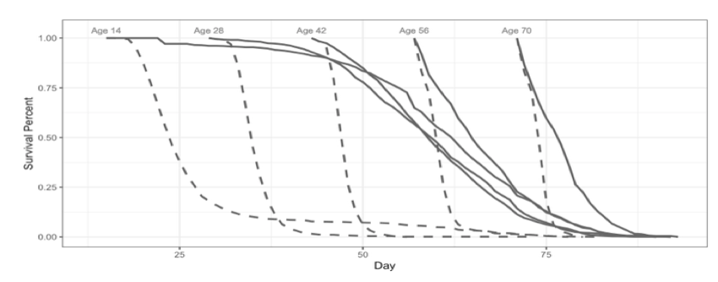

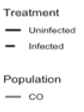

*Figure 4.2.* Comparison of survival percent of un-infected (solid lines) and infected (dash lines)

CO1-5 flies at age 14, 28, 42, 56, and 70 days. Y axis shows survival percent and X axis shows day.

B

A

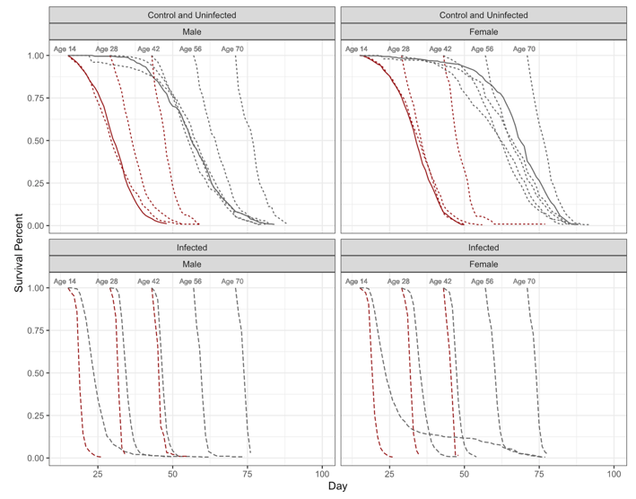

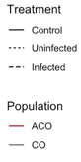

*Figure 5.1.* Survival percent of ACO1-5 and CO1-5 populations were compared together in these graphs. Comparison of all treatments was done for both male (panel A) and female (panel B) flies at age 14, 28, 42, 56, and 70 days. Treatments include control (solid lines), un-infected (dot lines), and infected (dash lines) flies. Control group did not spray at all, un-infected group was sprayed with silwet and infected group was sprayed with fungus. Y axis shows survival percent and X axis shows day.

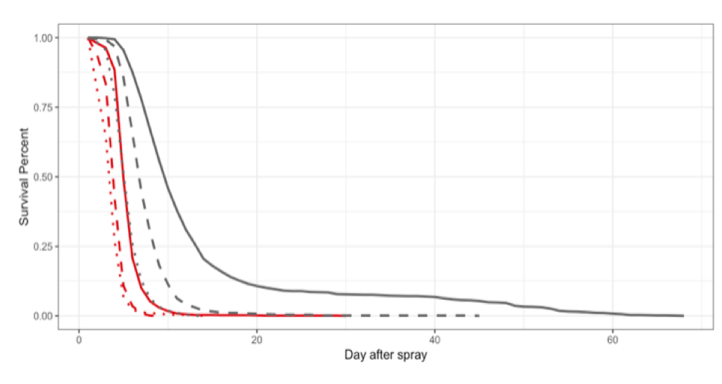

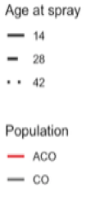

*Figure 5.2.* This graph displays survival percent of infected ACO1-5 (red lines) and CO1-5 (gray lines)populations at age 14 (solid lines), 28 (dash lines), and 42 (dot lines) days. Y axis displays survival percent and X axis shows day after spray. Comparison of infected ACO1-5 and CO1-5 flies demonstrates that survival percent of ACO1-5 populations at age 14 overlapped with survival percent of CO1-5 populations at age 42.

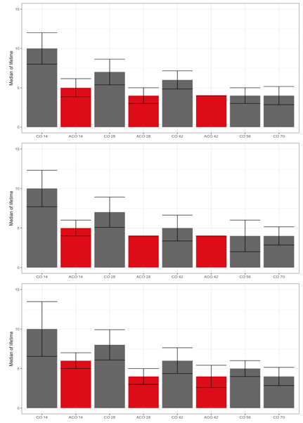

A

../Desktop/Screen%20Shot%202020-03-31%20at%208.46.27%20PM.png

../Desktop/Screen%20Shot%202020-03-31%20at%208.46.27%20PM.png

B

../Desktop/Screen%20Shot%202020-03-31%20at%208.46.27%20PM.png

C

*Figure 6*. Median life time of ACO1-5 (red boxes) and CO1-5 (gray boxes) populations were compared together at age 14, 28, 42, 56, and 70 days. Y axis shows median of lifetime and X axis shows populations’ name and ages. Panels A, B and C shows results for combined sexes, male, and female flies respectively.

Mortality graphs:

*Table 1.* glm(formula = dead.data.14 ~ day * selection * treatment + sex, family = binomial, data = day.14.rep.data) Deviance Residuals: Min (-12.7616 ), 1Q (-1.9441), Median (0.3964), 3Q (2.5077), Max (15.7815).

Signif. codes: 0 ‘***’ 0.001 ‘**’ 0.01 ‘*’ 0.05 ‘.’ 0.1 ‘ ’ 1 ,(Dispersion parameter for binomial family taken to be 1), Null deviance: 152724 on 1374 degrees of freedom, Residual deviance: 22628 on 1366 degrees of freedom,

AIC: 27901, Number of Fisher Scoring iterations: 6

|  |  |
| --- | --- |
| Coefficients: | Estimate Std. Error z value Pr(>|z|) |
| (Intercept)  *** | -4.36290 0.07034 -62.029 < 2e-16 |
| day  *** | 0.82880 0.01303 63.585 < 2e-16 |
| selectionco  *** | 2.67205 0.07281 36.697 < 2e-16 |
| treatmentuninfected  *** | 0.44030 0.07612 5.784 7.27e-09 |
| sexm  *** | 0.82155 0.01353 60.713 < 2e-16 |
| day:selectionco  *** | -0.71166 0.01308 -54.428 < 2e-16 |
| day:treatmentuninfected  *** | -0.62984 0.01311 -48.029 < 2e-16 |
| selectionco:treatmentuninfected  *** | -4.25634 0.08750 -48.644 < 2e-16 |
| day:selectionco:treatmentuninfected  *** | 0.62451 0.01319 47.365 < 2e-16 |
|  |  |

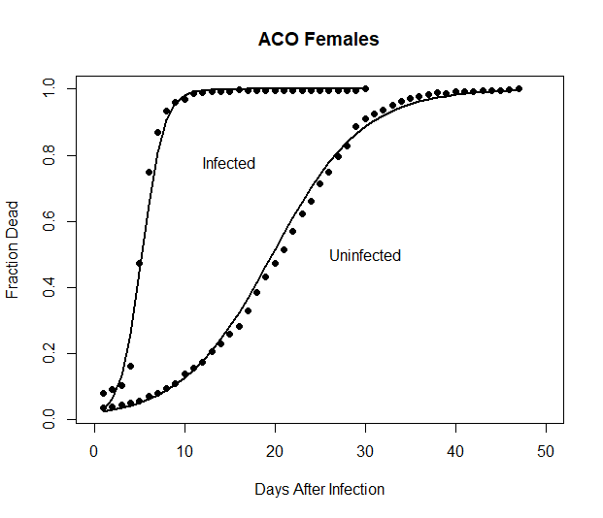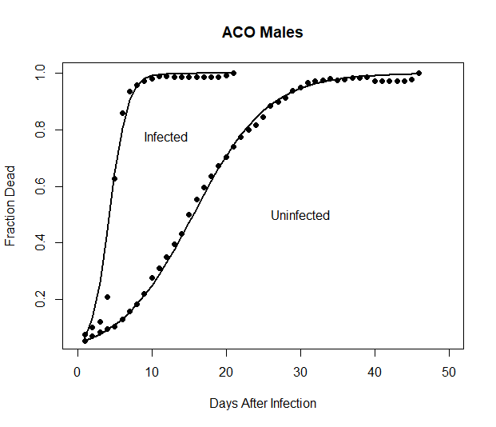

B

A

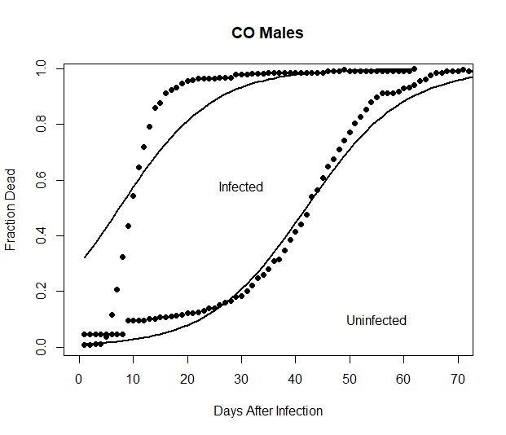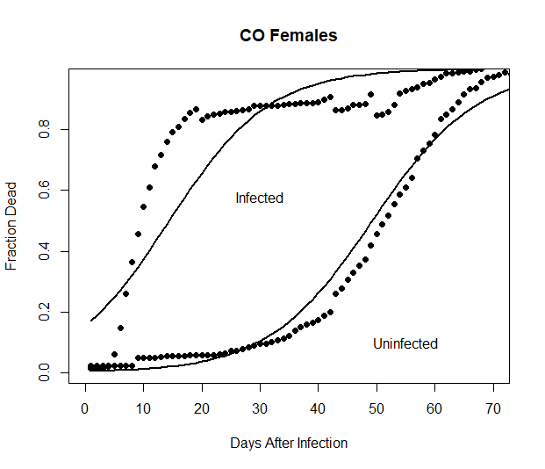

D

C

*Figure 7.* The solid lines are the GLM model prediction and the solid points are the mean observed fraction of dead flies over the four replicates. This graph shows the mortality rate comparison of infected and un-infected ACO1-5 and CO1-5 flies at age 14 days. Panels A and B shows result of ACO1-5 males and females respectively. Panels C and D displays mortality rates for CO1-5 males and females respectively. Y axis displays mortality rate and X axis shows days after infection.

*Table 2.* The table below gives the *t*50 for each of the selection-sex-treatment groups at age 14.

|  |  |  |  |  |  |  |
| --- | --- | --- | --- | --- | --- | --- |
| Selection Regime |  | Sex |  | Treatment |  | *t*50 (days) |
| CO |  | Male |  | Uninfected |  | 41.9 |
|  |  | Male |  | Infected |  | 7.42 |
| ACO |  | Male |  | Uninfected |  | 15.6 |
|  |  | Male |  | Infected |  | 4.27 |
| CO |  | Female |  | Uninfected |  | 49.3 |
|  |  | Female |  | Infected |  | 14.4 |
| ACO |  | Female |  | Uninfected |  | 19.7 |
|  |  | Female |  | Infected |  | 5.26 |

*Table 3.* Below the relevant differences in *t*50 values that assess the effects of selection regime are show. The difference between the ACO and CO controls is of course expected given the life cycle these two populations are kept on. The new result will be the differences between ACO and CO infected flies. If the confidence interval does not include zero we conclude that the difference is significantly different from 0.

|  |  |  |  |  |
| --- | --- | --- | --- | --- |
| Population Contrast interval | Sex | Treatment | Difference | 98.75% Confidence |
| CO-ACO | Male | Infected | 3.15 | (2.8, 3.5) |
| CO-ACO | Female | Infected | 9.14 | (8.9, 9.4) |
| CO-ACO | Male | Uninfected | 26.3 | (26.0, 26.6) |
| CO-ACO | Female | Uninfected | 29.6 | (29.2, 29.9) |

*Table 4*. Below we use subscripts “i” and “u” for infected and uninfected respectively at age 14.

|  |  |  |  |
| --- | --- | --- | --- |
| Population Contrast | Sex | Difference | 95% Confidence Interval |
| COu-COi | Male | 34.48 | (34.1, 34.9) |
| COu-COi | Female | 34.9 | (34.5, 35.2) |
| ACOu-ACOi | Male | 11.33 | (11.1, 11.5) |
| ACOu-ACOi | Female | 14.44 | (14.3, 14.6) |

*Table 5.* glm(formula = dead.data.28 ~ day * selection * treatment + sex, family = binomial, data = day.28.rep.data)Deviance Residuals: Min (-8.0053) , 1Q (-2.0373), Median (0.0127), 3Q (1.8645), Max (11.9496).

Signif. codes: 0 ‘***’ 0.001 ‘**’ 0.01 ‘*’ 0.05 ‘.’ 0.1 ‘ ’ 1, (Dispersion parameter for binomial family taken to be 1), Null deviance: 81304.9 on 867 degrees of freedom, Residual deviance: 8846.6 on 859 degrees of

Freedom, AIC: 12194, Number of Fisher Scoring iterations: 6

|  |  |
| --- | --- |
| Coefficients: |  |
|  | Estimate Std. Error z value Pr(>|z|) |
| (Intercept)  *** | -4.04290 0.08428 -47.972 <2e-16 |
| day  *** | 1.15467 0.02223 51.946 <2e-16 |
| selectionco | 0.09959 0.10539 0.945 0.345 |
| treatmentuninfected  *** | 1.91240 0.08943 21.384 <2e-16 |
| sexm  *** | 0.24235 0.01731 14.003 <2e-16 |
| day:selectionco  *** | -0.61154 0.02372 -25.777 <2e-16 |
| day:treatmentuninfected  *** | -0.87250 0.02245 -38.868 <2e-16 |
| selectionco:treatmentuninfected  *** | -1.78881 0.11489 -15.570 <2e-16 |
| day:selectionco:treatmentuninfected  *** | 0.45345 0.02396 18.929 <2e-16 |

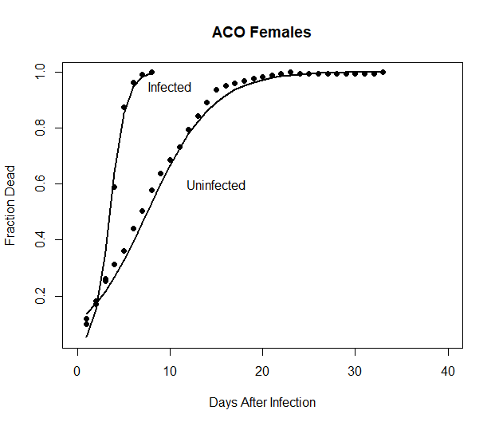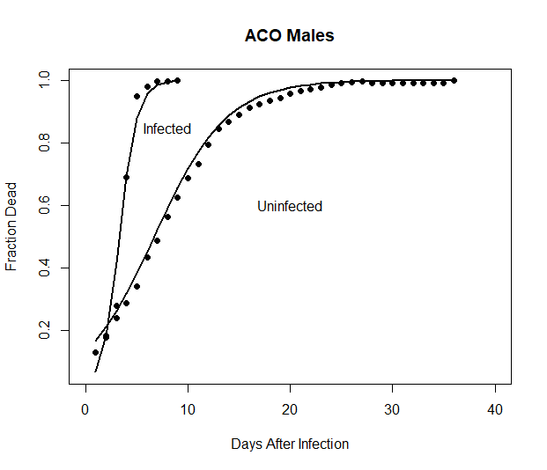

B

A

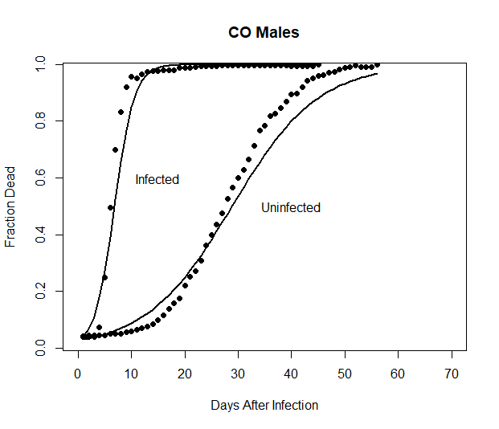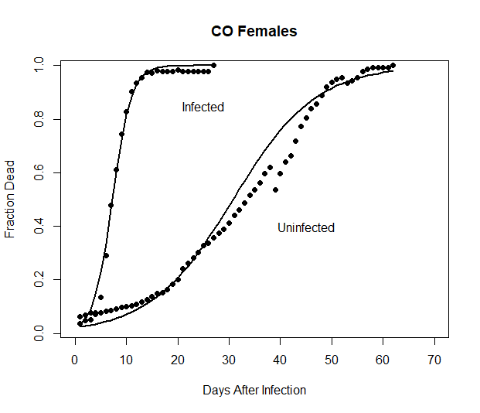

D

C

*Figure 8.* The solid lines are the GLM model prediction and the solid points are the mean observed fraction of dead flies over the four replicates. This graph shows the mortality rate comparison of infected and un-infected ACO1-5 and CO1-5 flies at age 28 days. Panels A and B shows result of ACO1-5 males and females respectively. Panels C and D displays mortality rates for CO1-5 males and females respectively. Y axis displays mortality rate and X axis shows days after infection.

*Table 6.* The table below gives the *t*50 for each of the selection-sex-treatment groups at age 28.

|  |  |  |  |  |  |  |
| --- | --- | --- | --- | --- | --- | --- |
| Selection Regime |  | Sex |  | Treatment |  | *t*50 (days) |
| CO |  | Male |  | Uninfected |  | 28.8 |
|  |  | Male |  | Infected |  | 6.81 |
| ACO |  | Male |  | Uninfected |  | 6.69 |
|  |  | Male |  | Infected |  | 3.29 |
| CO |  | Female |  | Uninfected |  | 30.8 |
|  |  | Female |  | Infected |  | 7.26 |
| ACO |  | Female |  | Uninfected |  | 7.55 |
|  |  | Female |  | Infected |  | 3.50 |

*Table 7*. Below the relevant differences in *t*50 values that assess the effects of selection regime are show. The difference between the ACO and CO controls is of course expected given the life cycle these two populations are kept on. The new result will be the differences between ACO and CO infected flies. If the confidence interval does not include zero we conclude that the difference is significantly different from 0.

|  |  |  |  |  |
| --- | --- | --- | --- | --- |
| Population Contrast interval | Sex | Treatment | Difference | 98.75% Confidence |
| CO-ACO | Male | Infected | 3.52 | (3.4, 3.7) |
| CO-ACO | Female | Infected | 3.76 | (3.6, 3.9) |
| CO-ACO | Male | Uninfected | 22.11 | (21.8, 22.4) |
| CO-ACO | Female | Uninfected | 23.25 | (22.9, 23.5) |

*Table 8*. Below we use subscripts “i” and “u” for infected and uninfected respectively at age 28.

|  |  |  |  |
| --- | --- | --- | --- |
| Population Contrast | Sex | Difference | 95% Confidence Interval |
| COu-COi | Male | 21.99 | (21.7, 22.3) |
| COu-COi | Female | 23.54 | (23.2, 23.8) |
| ACOu-ACOi | Male | 3.40 | (3.23, 3.57) |
| ACOu-ACOi | Female | 4.05 | (3.89, 4.21) |

*Table 9*. glm(formula = dead.data.42 ~ day * treatment + sex, family = binomial, data = day.42.rep.data)Deviance Residuals: Min (-9.2753), 1Q (-1.8897), Median (-0.0563), 3Q (1.7828) , Max (7.8441). Signif. codes: 0 ‘***’ 0.001 ‘**’ 0.01 ‘*’ 0.05 ‘.’ 0.1 ‘ ’ 1, (Dispersion parameter for binomial family taken to be 1)Null deviance: 33229.2 on 389 degrees of freedom, Residual deviance: 3470.5 on 385 degrees of freedom

AIC: 5039.7, Number of Fisher Scoring iterations: 5

|  |
| --- |
| Coefficients: |
| Estimate Std. Error z value Pr(>|z|) |
|  |
|  |
| (Intercept) -5.27240 0.09444 -55.83 <2e-16 *** |
| day 0.95569 0.01727 55.34 <2e-16 *** |
| treatmentuninfected 1.94957 0.09729 20.04 <2e-16 *** |
| sexm 1.01991 0.02614 39.02 <2e-16 *** |
| day:treatmentuninfected -0.78349 0.01730 -45.28 <2e-16 *** |
|  |

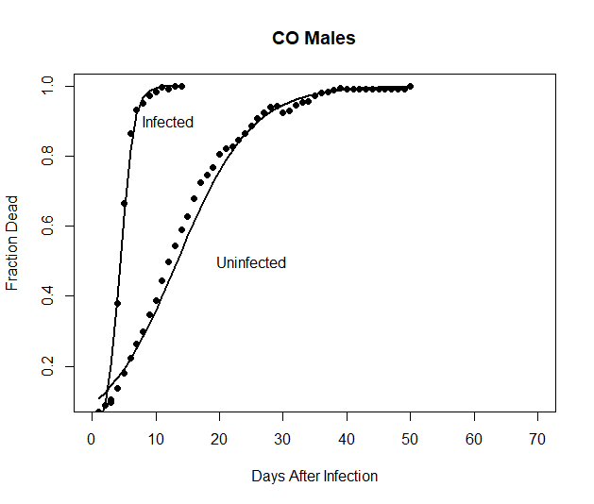

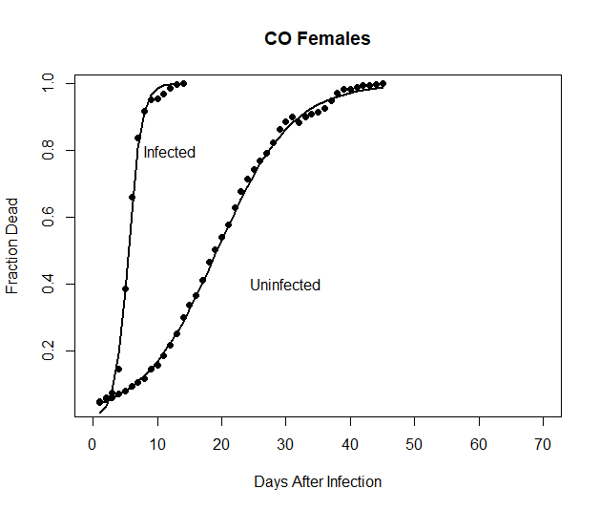

B

A

*Figure 9.* The solid lines are the GLM model prediction and the solid points are the mean observed fraction of dead flies over the four replicates. This graph shows the mortality rate comparison of infected and un-infected CO1-5 flies at age 42 days. Panels A and B shows result of CO1-5 males and females respectively. Y axis displays mortality rate and X axis shows days after infection.

*Table 10.* The table below gives the *t*50 for each of the selection-sex-treatment groups at age 42.

|  |  |  |  |  |  |
| --- | --- | --- | --- | --- | --- |
| Selection Regime | Sex |  | Treatment |  | *t*50 (days) |
| CO | Male |  | Uninfected |  | 13.4 |
|  | Male |  | Infected |  | 4.45 |
| CO | Female |  | Uninfected |  | 19.3 |
|  | Female |  | Infected |  | 5.52 |

*Table 11*. Below we use subscripts “i” and “u” for infected and uninfected respectively at age 42.

|  |  |  |  |  |  |
| --- | --- | --- | --- | --- | --- |
| Population Contrast | Sex |  | Difference |  | 95% Confidence Interval |
| COu-COi | Male |  | 8.95 |  | (8.63, 9.21) |
|  |  |  |  |  |  |
| COu-COi | Female |  |  |  |  |
|  |  |  | 13.78 |  | (13.5, 14.0) |

*Table 12*. glm(formula = dead.data.56 ~ day * treatment + sex, family = binomial, data = day.56.rep.data)

Deviance Residuals: Min (-7.527) ,1Q (-1.236), Median (0.192), 3Q (1.454) ,Max (6.795) . Signif. codes: 0 ‘***’ 0.001 ‘**’ 0.01 ‘*’ 0.05 ‘.’ 0.1 ‘ ’ 1, (Dispersion parameter for binomial family taken to be 1), Null deviance: 15998.6 on 330 degrees of freedom, Residual deviance: 1580.4 on 326 degrees of freedom

AIC: 2836.9, Number of Fisher Scoring iterations: 5

|  |
| --- |
| Coefficients: |
| Estimate Std. Error z value Pr(>|z|) |
| (Intercept) -1.84784 0.05237 -35.287 < 2e-16 *** |
| day 0.52125 0.01043 49.974 < 2e-16 *** |
| treatmentuninfected 0.18062 0.06125 2.949 0.00319 ** |
| sexm 0.49985 0.03183 15.704 < 2e-16 *** |
| day:treatmentuninfected -0.32702 0.01078 -30.331 < 2e-16 *** |

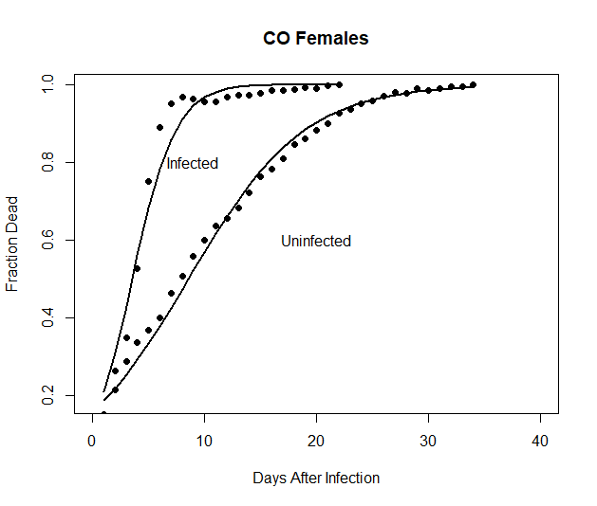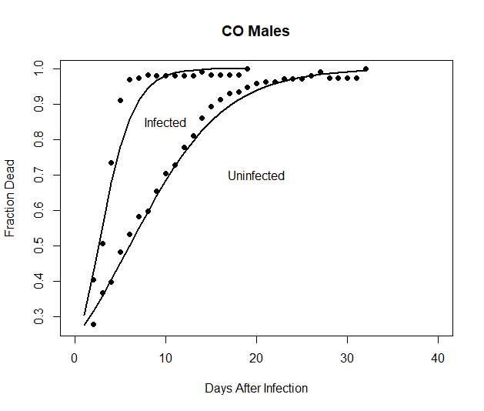

B

A

*Figure 10.* The solid lines are the GLM model prediction and the solid points are the mean observed fraction of dead flies over the four replicates. This graph shows the mortality rate comparison of infected and un-infected CO1-5 flies at age 56 days. Panels A and B shows result of CO1-5 males and females respectively. Y axis displays mortality rate and X axis shows days after infection.

*Table 13*. The table below gives the *t*50 for each of the selection-sex-treatment groups at age 56.

|  |  |  |  |  |  |  |
| --- | --- | --- | --- | --- | --- | --- |
| Selection Regime |  | Sex |  | Treatment |  | *t*50 (days) |
| CO |  | Male |  | Uninfected |  | 6.01 |
|  |  | Male |  | Infected |  | 2.59 |
| CO |  | Female |  | Uninfected |  | 8.58 |
|  |  | Female |  | Infected |  | 3.55 |

*Table 14.* Below we use subscripts “i” and “u” for infected and uninfected respectively at age 56.

|  |  |  |  |  |  |
| --- | --- | --- | --- | --- | --- |
| Population Contrast | Sex |  | Difference |  | 95% Confidence Interval |
| COu-COi | Male |  | 3.42 |  | (3.06, 3.77) |
|  |  |  |  |  |  |
| COu-COi | Female |  | 5.03 |  | (4.76, 5.32) |
|  |  |  |  |  |  |

*Table 15.* glm(formula = dead.data.70 ~ day * treatment + sex, family = binomial, data = day.70.rep.data)

Deviance Residuals: Min (-4.1850), 1Q (-0.8634), Median (0.0756), 3Q (0.9714), Max (5.7508). Signif. codes: 0 ‘***’ 0.001 ‘**’ 0.01 ‘*’ 0.05 ‘.’ 0.1 ‘ ’ 1, (Dispersion parameter for binomial family taken to be 1), Null deviance: 5946.25 on 205 degrees of freedom, Residual deviance: 423.74 on 201 degrees of freedom

AIC: 1093.8, Number of Fisher Scoring iterations: 4

|  |
| --- |
| Coefficients: |
| Estimate Std. Error z value Pr(>|z|) |
| (Intercept) -1.79418 0.08284 -21.660 < 2e-16 *** |
| day 0.71960 0.02240 32.119 < 2e-16 *** |
| treatmentuninfected 0.55745 0.09540 5.843 5.12e-09 *** |
| sexm 0.20420 0.05598 3.648 0.000264 *** |
| day:treatmentuninfected -0.42736 0.02326 -18.370 < 2e-16 *** |

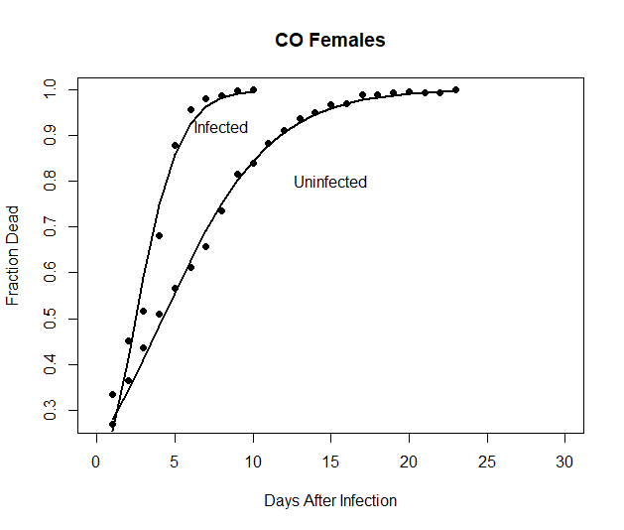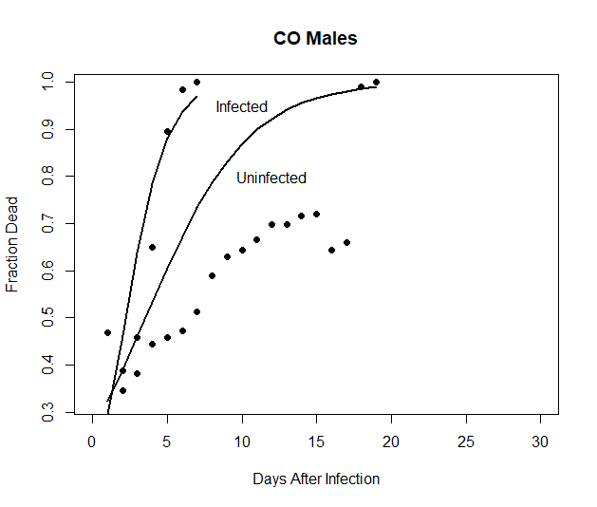

B

A

*Figure 11.* The solid lines are the GLM model prediction and the solid points are the mean observed fraction of dead flies over the four replicates. This graph shows the mortality rate comparison of infected and un-infected CO1-5 flies at age 70 days. Panels A and B shows result of CO1-5 males and females respectively. Y axis displays mortality rate and X axis shows days after infection.

*Table 16*. The table below gives the *t*50 for each of the selection-sex-treatment groups at age 70.

|  |  |  |  |  |  |  |
| --- | --- | --- | --- | --- | --- | --- |
| Selection Regime |  | Sex |  | Treatment |  | *t*50 (days) |
| CO |  | Male |  | Uninfected |  | 3.53 |
|  |  | Male |  | Infected |  | 2.21 |
| CO |  | Female |  | Uninfected |  | 4.23 |
|  |  | Female |  | Infected |  | 2.49 |

*Table 17*. Below we use subscripts “i” and “u” for infected and uninfected respectively at age 70.

|  |  |  |  |  |  |
| --- | --- | --- | --- | --- | --- |
| Population Contrast | Sex |  | Difference |  | 95% Confidence Interval |
| COu-COi | Male |  | 1.32 |  | (0.92, 1.71) |
|  |  |  |  |  |  |
| COu-COi | Female |  | 1.74 |  | (1.43, 2.03) |
|  |  |  |  |  |  |

Chapter 4

Discussion:

).

Studies of aging that compare young and old flies from the same population are looking at “chronological” aging, which can be affected by extended interactions with the biotic and abiotic factors in the environment. Populations that have evolved to age at different rates may allow us to separate biological aging from the effects of time and cumulative exposure. In this study, we examined the effects of chronological aging and biological aging on immune defense in *Drosophila melanogaster*. When we study immune aging, it is very important to verify the changes that happen for the immune system is because of accumulation of environmental effects and hazardous over time or it is because of aging. Then, in this study by monitoring the mortality rate of ACO and CO populations at different ages, we could find out the effect of both chronological and biological aging on innate immune. As we observed in this study CO populations have stronger immunity than ACO populations which means long-lived individuals have better immune defense than short-lived flies (I need data analysis from Han to complete this part and make sure this is correct or not/ I just wrote it based on our expectation). As we used two different populations which evolved with different longevities, we can refer our results as effect of aging on innate immunity and we know immunity weakness in this study did not happen only based on overwhelming of environmental effects during the time.

Some studies show improvement of innate immunity by aging while some others display weakness of immune defense by aging. Deteriorating processes that accompany aging highly effect on the Drosophila immune system. Some of these processes that contribute to the functional senescence are includes chronic inflammation, steady weakening of protective epithelial barriers, and a loss of cellular immunity which increased pathogen susceptibility of aging flies (Müller et al., 2013; Eleftherianos & Castillo, 2012). Another study on immune aging described that fungal infection susceptibility increase in flies of both sexes as they age. In male flies this happens because of barrier defences’ deterioration while the systemic immune senescence is chiefly responsible for female flies (Kubiak & Tinsley, 2017). There are some other studies that believe improvement of immunity by aging. One of these studies described that the gut specific provocation of Drosocin and Cecropin A1 is necessary to notably extend lifetime of adult flies.  Decrease of bacterial challenges upon expression of *Dro* is responsible for intestinal barrier improvement which postpone intestinal and organismal ageing and lastly cause longer lifespan of flies (Loch et al., 2017).

Long-lived flies have better immunity upon infection (Fabian et.al 2018). In Fabian et al., (2018) , they used 4 long-lived selection lines (La, Lb, 2La, 2Lb) and 2 unselected control lines (Ra, Rb). These populations were taken from an outbred base population which was founded in 1979 from ~50 flies caught in a peach orchard in Michigan. The base population was then expanded, divided into replicate lines, and selection was originated in 1981. To examine whether selected and control flies vary in recognized immune function, they infected their populations with four different pathogens and measured their survival percent after infection. Then, they found out long-lived flies have better survival upon infection. This study supports Fabian et al., (2018) but we used different populations of *Drosophila*. We used five replicates of ACO and five replicates of CO populations which helped us to examine effect of aging on innate immunity more accurate than Fabian et al., (2018) which only used 4 long-lived and 2 control populations. Moreover, our study is focused on fungal infection and we used specific methods for our fungal spray which is different than Fabian et al., (2018).

In this study, *B.bassiana* strain, ARSEF 12460, was used to infected ACO and CO populations while some other studies focused on bacterial infection and bacterial clearance ability in *Drosophila* (Fabian et.al 2018). As expected from the evolutionary theories of aging and late life, our mortality results show that among control flies, the ACO die faster than the CO, which support the theory that populations with different first age of reproduction have different longevity and mortality plateau.

The ACO1-5 and CO1-5 populations also differ from each other genomically (Graves et.al 2017). Genomic analysis that focused on single nucleotide polymorphisms (SNPs) and heterozygosity within and between ACO1-5 and CO1-5 populations demonstrated that mean heterozygosity in ACO1-5 populations is lower than CO1-5 populations which could be because of more intense A-type selection. However, a significant variation of SNPs and heterozygosity was observed between ACO1-5 and CO1-5 populations. Comparison of A versus C displayed 10109 significant SNPs (Graves et.al 2017).

Fabian et.al. 2018 suggests that populations that are differentiated for longevity are also differentiated for immune defense genes. In this study, also the genomic differentiation of CO vs ACO will be enriched for immune defense genes. We used different methods for our genome wide analysis. In the beginning, we got results from wang et al., (2017) and put their gene list into flybase. Then, obtained a list of 117 genes and compared them to the list of significant SNPs between A and C. As a result, it returned 13 genes which is less than 10% of the list and it may be due to chance. (Dear parvin at the end of discussion, I added some parts of Fabian genomic analysis process. However, I was confused how use it for my project. I appreciate if help me with it).

In studies of age-specific physiology, including ours on age-specific immune defense, it should be kept in mind that for a period of 10 days, flies that are near death enter a phase that has been called the “death spiral” (Meuller et.al 2016). When in the death spiral, female fecundity and male virility drop significantly below that of same-aged individuals who are not near death. Several phenotypes are also known to deteriorate substantially in dying individuals, regardless of the actual age at death, including time in motion and negative geotaxis ability (Shahrestani et al. 2012). In other words, the death spiral is a period before death during which physiological characters and life-history characters decline (Meuller et.al 2016). When individuals who are near death at any given age are eliminated from estimates of age-specific fecundity and virility, these characters still continue to decline during aging, suggesting that the age-specific decline in these characters does not result from more and more individuals entering the dying phases at older ages (Mueller et al. 2007). We expect that the age-specific decline we see in immune defense also should be independent of individuals who are dying, even if the dying individuals change the shape of the curves qualitatively.

Some parts of Fabian genomic analysis process:

To analyze the genomes of the selection and control lines we used Pool-Seq(Schlötterer et al. 2014). For each replicate line, we extracted DNA from pools of 100 females using the Qiagen DNeasy Blood and Tissue Kit and subsequent fragmentation with a Covaris S2 ultra sonicator (Covaris).

To define candidate SNPs that are likely shaped by selection we applied a highly stringent *F*ST outlier approach (Akey 2009; Lewontin and Krakauer 1973)to all 1,307,590 polymorphic sites, using *PoPoolation2*(Kofler et al. 2011b). Alleles occurring less than 12 times across all six lines (average minimum count of 2 per line) were excluded. SNPs were deemed to represent candidates if their frequencies were (i) strongly and consistently differentiated between the selection and control regimes, with an *F*ST > 0.9 in all 8 possible pairwise comparisons of the 2 control lines with the 4 selection lines (Fig. 1a) and (ii) significantly different between regimes in a Fisher's exact test (at = 0.001) with Bonferroni correction (p< ' = 0.001 / 1,307,590 = 7.65 x 10-10). This yielded 8205 candidate SNPs in 868 genes. In addition to defining candidates, we estimated the strength of differentiation among selection versus control lines relative to differentiation within selection or control lines by calculating a ‘selection signal-to-noise’ ratio for each polymorphic SNP, with the ratio ranging from 1 to -1

We performed a number of downstream analyses on our candidate set of SNPs. First, to identify differences in the proportion of genomic features of candidates versus whole-genome background, we obtained gene names and annotations for the candidates from FlyBase r.5.40 with *SnpEff* (v.2.0.3; Cingolani et al. 2012). To account for potential regulatory variants up- or downstream of the gene body we considered all sequence variants within 1 kb distance of the 5’ and 3’UTR as being part of a given candidate gene; variants outside of these borders were considered to be intergenic. The analyzed ‘candidate gene’ sequences thus include both synonymous and non-synonymous SNPs as well as exons and introns. Second, to examine the functions of the candidate genes and test for gene set enrichment we used gene ontology (GO) analysis in *Gowinda* (Kofler and Schlötterer 2012), accounting for gene length bias. Genes were mapped to GO terms with *GoMiner*(Zeeberg et al. 2003), using the reference genome v.5.40 for annotations. We considered the ontologies ‘Biological Function’, ‘Molecular Function’ and ‘Cellular Component’. Finally, to investigate ‘gene reuse’, i.e. the extent to which genetic loci underlying the evolution of *Drosophila* lifespan might be shared (‘public’) or lineage/population-specific (‘private’) (DeVeale et al. 2004; Partridge and Gems 2002), we compared our list of candidate genes to those from two 'Evolve and Resequence' (E&R) studies (Carnes et al. 2015; Remolina et al. 2012)similar to ours (Luckinbill et al. 1984). To do so, we first created uniform gene names using the Flybase Upload/Convert IDs tool (v.FB2014_03; http://flybase.org/convert/id) and then calculated all possible overlaps between the three gene lists using the R package *SuperExactTest*(Wang et al. 2015), assuming a shared background of 12,007 genes in the normally recombining genome(Kolaczkowski et al. 2011, also cf. Table S5).

References:

Johnson, F. B., Sinclair, D. A., & Guarente, L. (1999). Molecular biology of aging. *Cell*, *96*(2), 291-302.

Gladyshev, V. N. (2013). The origin of aging: imperfectness-driven non-random damage defines the aging process and control of lifespan. *Trends in genetics*, *29*(9), 506-512.

Gladyshev, V. N. (2013). The origin of aging: imperfectness-driven non-random damage defines the aging process and control of lifespan. *Trends in genetics*, *29*(9), 506-512.

Stadtman, E. R. (1992). Protein oxidation and aging. *Science*, *257*(5074), 1220-1224.

Rose, M. R., Burke, M. K., Shahrestani, P., & Mueller, L. D. (2008). Evolution of ageing since

Darwin. *Journal of genetics*, *87*(4), 363.

Rose, M. R. (1984). Laboratory evolution of postponed senescence in Drosophila melanogaster. *Evolution*, *38*(5), 1004-1010.

Rose, M. R., & Mueller, L. D. (2000). Ageing and immortality. *Philosophical Transactions of the Royal Society of London. Series B: Biological Sciences*, *355*(1403), 1657-1662.

Mueller, L. D., & Rose, M. R. (1996). Evolutionary theory predicts late-life mortality plateaus. *Proceedings of the National Academy of Sciences*, *93*(26), 15249-15253.

Kounatidis, I., & Ligoxygakis, P. (2012). Drosophila as a model system to unravel the layers of innate immunity to infection. *Open biology*, *2*(5), 120075.

Buchon, N., Silverman, N., & Cherry, S. (2014). Immunity in Drosophila melanogaster—from microbial recognition to whole-organism physiology. *Nature reviews immunology*, *14*(12), 796-810.

Kleino, A., & Silverman, N. (2014). The Drosophila IMD pathway in the activation of the humoral immune response. *Developmental & Comparative Immunology*, *42*(1), 25-35.

Sookar, P., Bhagwant, S., & Awuor Ouna, E. (2008). Isolation of entomopathogenic fungi from the soil and their pathogenicity to two fruit fly species (Diptera: Tephritidae). *Journal of Applied Entomology*, *132*(9‐10), 778-788.

Garschall, K., & Flatt, T. (2018). The interplay between immunity and aging in Drosophila. *F1000Research*, *7*.

Chippindale, A. K., Alipaz, J. A., Chen, H. W., & Rose, M. R. (1997). Experimental evolution of accelerated development in Drosophila. 1. Developmental speed and larval survival. *Evolution*, *51*(5), 1536-1551.

Shahrestani, P., Quach, J., Mueller, L. D., & Rose, M. R. (2012). Paradoxical physiological transitions from aging to late life in Drosophila. *Rejuvenation research*, *15*(1), 49-58.

Rauser, C. L., Tierney, J. J., Gunion, S. M., Covarrubias, G. M., Mueller, L. D., & Rose, M. R. (2006). Evolution of late‐life fecundity in Drosophila melanogaster. *Journal of Evolutionary Biology*, *19*(1), 289-301.

Zerofsky, M., Harel, E., Silverman, N., & Tatar, M. (2005). Aging of the innate immune response in Drosophila melanogaster. *Aging cell*, *4*(2), 103-108.

Ramsden S, Cheung YY, Seroude L. Functional analysis of the *Drosophila* immune response during aging. *Aging Cell.* 2008;7:225–236.

Lesser KJ, Paiusi IC, Leips J. Naturally occurring genetic variation in the age-speci c immune response of *Drosophila melanogaster*. *Aging Cell.* 2006;5:293–295.

Khan, I., & Prasad, N. G. (2013). The aging of the immune response in Drosophila melanogaster. *Journals of Gerontology Series A: Biomedical Sciences and Medical Sciences*, *68*(2), 129-135.

Mueller, L. D., Rauser, C. L., & Rose, M. R. (2007). An evolutionary heterogeneity model of late-life fecundity in Drosophila. *Biogerontology*, *8*(2), 147-161.

Shahrestani, P., Wilson, J. B., Mueller, L. D., & Rose, M. R. (2016). Patterns of physiological decline due to age and selection in Drosophila melanogaster. *Evolution*, *70*(11), 2550-2561.

Shahrestani, P., Burke, M. K., Birse, R., Kezos, J. N., Ocorr, K., Mueller, L. D., ... & Bodmer, R. (2017). Experimental evolution and heart function in Drosophila. *Physiological and Biochemical Zoology*, *90*(2), 281-293.

Müller, L., Fülöp, T., & Pawelec, G. (2013). Immunosenescence in vertebrates and invertebrates. *Immunity & ageing*, *10*(1), 12.

Eleftherianos, I., & Castillo, J. C. (2012). Molecular mechanisms of aging and immune system regulation in Drosophila. *International journal of molecular sciences*, *13*(8), 9826-9844.

Kubiak, M., & Tinsley, M. C. (2017). Sex-specific routes to immune senescence in Drosophila melanogaster. *Scientific reports*, *7*(1), 1-7.

Loch, G., Zinke, I., Mori, T., Carrera, P., Schroer, J., Takeyama, H., & Hoch, M. (2017). Antimicrobial peptides extend lifespan in Drosophila. *PloS one*, *12*(5).

Mueller, L. D., Shahrestani, P., Rauser, C. L., & Rose, M. R. (2016). The death spiral: predicting death in Drosophila cohorts. *Biogerontology*, *17*(5-6), 805-816.

Shahrestani, P., Quach, J., Mueller, L. D., & Rose, M. R. (2012). Paradoxical physiological transitions from aging to late life in Drosophila. *Rejuvenation research*, *15*(1), 49-58.